CSCI 5380 - Network Virtualization and Orchestration

Lab 8
BGP SDN

University of Colorado Boulder
Department of Computer Science
Network Engineering

Professor Levi Perigo, Ph.D.

Summary:

In this Lab, you will configure BGP in a virtualized, traditional, and SDN. See Figure 1.

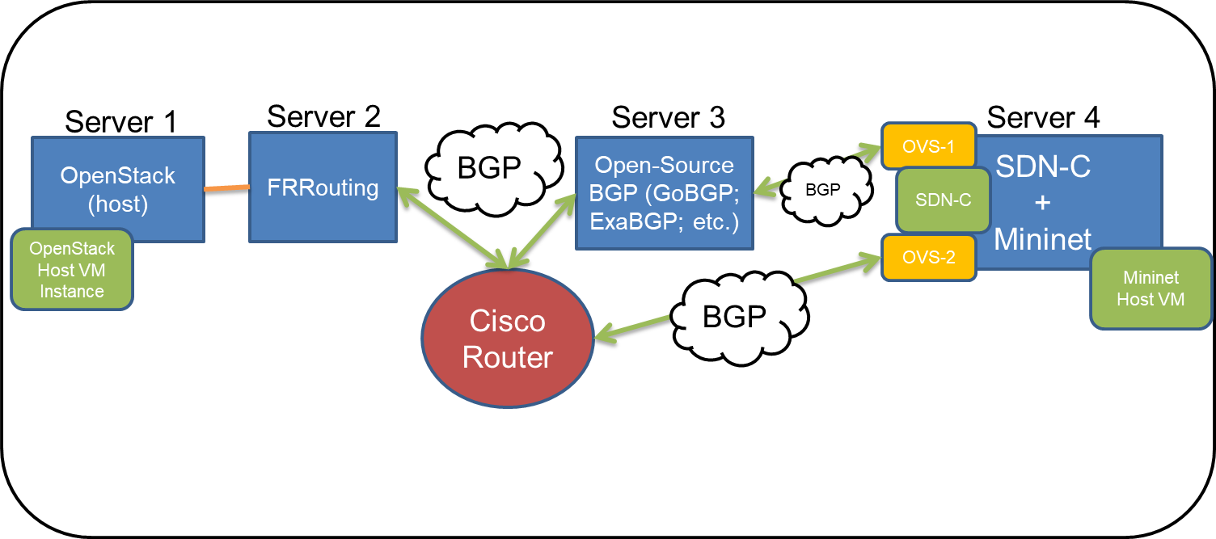
Figure 1: Lab environment

Each team will use one Cisco router and four servers running-
- OpenStack
- FRRouting [https://frrouting.org/]
- SDN Controller (Ryu) + Mininet
- Open-Source BGP (your choice)

Section 1 - Establish BGP Peering between FRRouting and Cisco router:

Configure BGP on FRRouting server and establish peering with the Cisco router.
[FRRouting is forked from Quagga and the installation process is the same. You can refer this document and replace Quagga with FRRouting -
http://www.brianlinkletter.com/how-to-build-a-network-of-linux-routers-using-quagga/ ]

Section 2 - Establish BGP Peering between Cisco Router and Open-Source BGP speaker:

Configure BGP on Cisco Router and establish a peering relationship of the Open-Source BGP speaker of your choice (GoBGP or ExaBGP recommended).

Section 3 – Establish BGP Peering between Open-Source BGP speaker and SDN Controller AND between Cisco Router and SDN Controller
In this objective, the SDN controller will need to dynamically add flow table entries (“routes”) to the Mininet OvS based on the peers. Failover should be accounted for (i.e. if the Open-Source speaker peering sessions goes down, all traffic should be routed through the other BGP peer).

Section 4 - IP Connectivity from VM to SDN:

The objective is to achieve communication between a Mininet host (Server 4) and an OpenStack instance (Server 1).

Final Deliverable
- Indicate via code that OpenStack host machine (host1) has connectivity to Mininet Host (host2), noting the correct hop/paths along the way.
  - BGP failover path must be accounted for.

Section 5 – [Extra Credit] BGP via Containers

Implement one of the sections/objectives in containerized form.

Section 6 – [Extra Credit] BGP via OpenStack

Implement BGP on the OpenStack server.

